# Login Page

https://idtheftdefensestage.mysecuredashboard.com/login

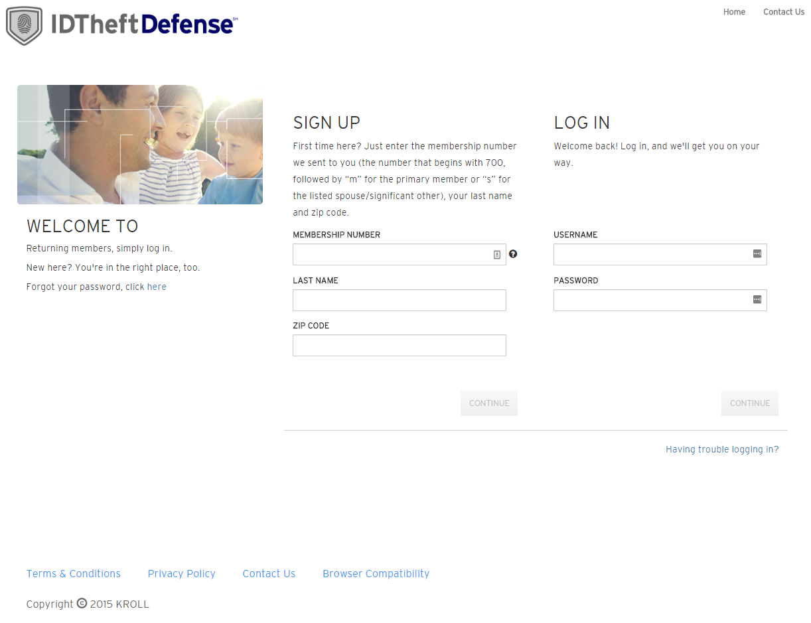

|  |  |  |
| --- | --- | --- |
| **PAGE ELEMENT** | **MULTI-CLIENT?** | **IDTD CONTENT** |
| Logo | Yes | [Link](https://keep.corp.kroll.com/sites/KBS_Fraud/operations/ICE/Partners/Primerica_900000151/Site%20Assets/Primerica-IDTheftDefenseLogo-800x133.png) *– Universal on all client’s pages* |
| Favicon | Yes | [Link](https://keep.corp.kroll.com/sites/KBS_Fraud/operations/ICE/Partners/Primerica_900000151/Site%20Assets/favicon.png) *– Universal on all client’s pages* |
| Page Title | Yes | PRIMERICA’s Portal – Sign In |
| Copyright disclaimer | No | Copyright © 2016 KROLL. All rights reserved. *– Universal on all client’s pages* |
| Feature image | Yes | [Family photo link](https://keep.corp.kroll.com/sites/KBS_Fraud/operations/ICE/Partners/Primerica_900000151/Site%20Assets/Primerica-1.jpg) |
| Welcome section | Yes | **Welcome to ID Theft Defense**  Returning members, simply log in.  New here? You’re in the right place, too.  Forgot your password, click here [Link to having trouble logging in page]. |
| Signup section | Yes | **SIGN UP**  First time here? We’ll get you started quickly. Just enter the membership number we sent you (followed by “m” for the primary member or “s” for the listed spouse/significant other) plus your last name and zip code. |
| Login section | Yes | **LOG IN**  Welcome back! Log in, and we'll get you on your way. |

# Contact Us

https://idtheftdefensestage.mysecuredashboard.com/contact-us

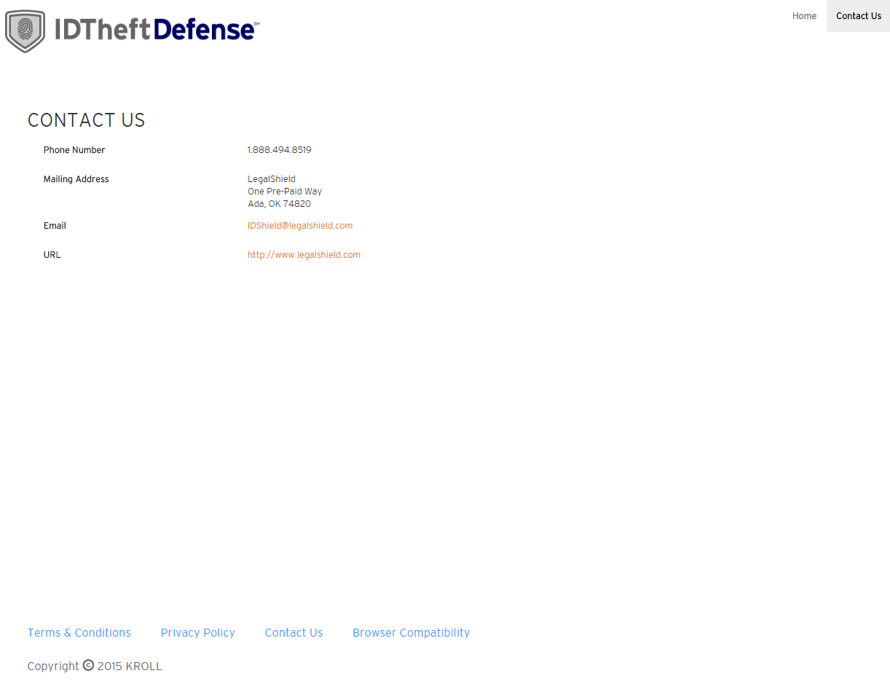

|  |  |  |
| --- | --- | --- |
| **PAGE ELEMENT** | **MULTI-CLIENT?** | **IDTD CONTENT** |
| Page Title | Yes | PRIMERICA’s Portal – Contact Us |
| Phone number | Yes | 844-319-8088 |
| Mailing Address | Yes | PRIMERICA 1 Primerica Parkway Duluth, GA 30099 |

# Terms and Conditions

https://idtheftdefensestage.mysecuredashboard.com/terms-and-conditions

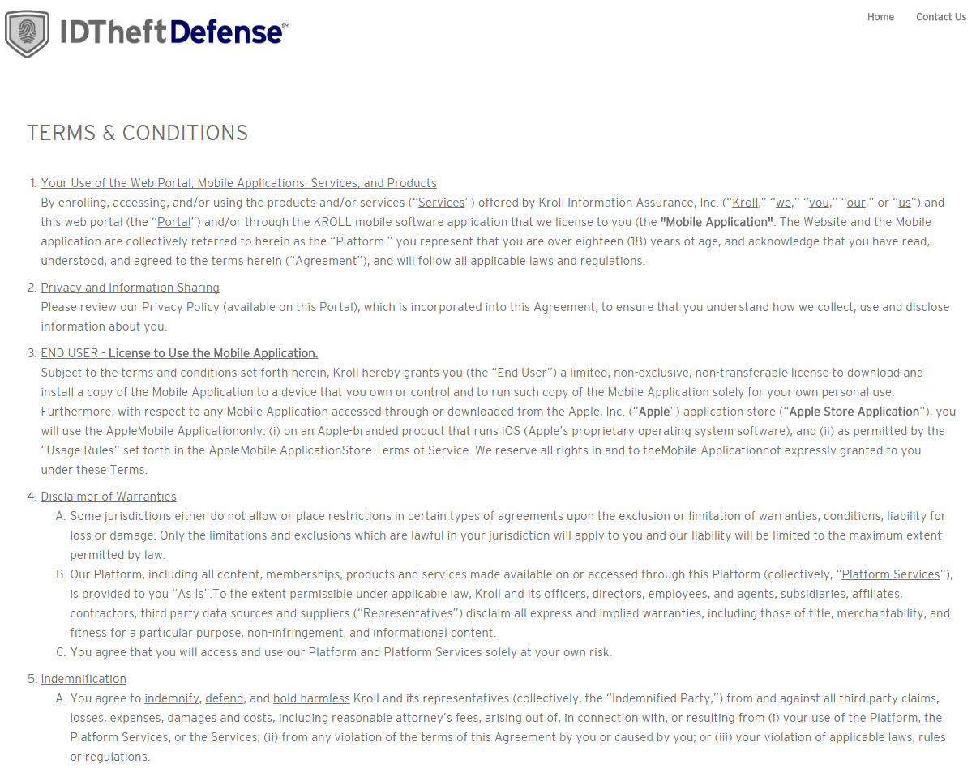

|  |  |  |
| --- | --- | --- |
| **PAGE ELEMENT** | **MULTI-CLIENT?** | **IDTD CONTENT** |
| Page Title | Yes | PRIMERICA’s Portal – Terms & Conditions |

# Privacy Policy

https://idtheftdefensestage.mysecuredashboard.com/privacy-policy

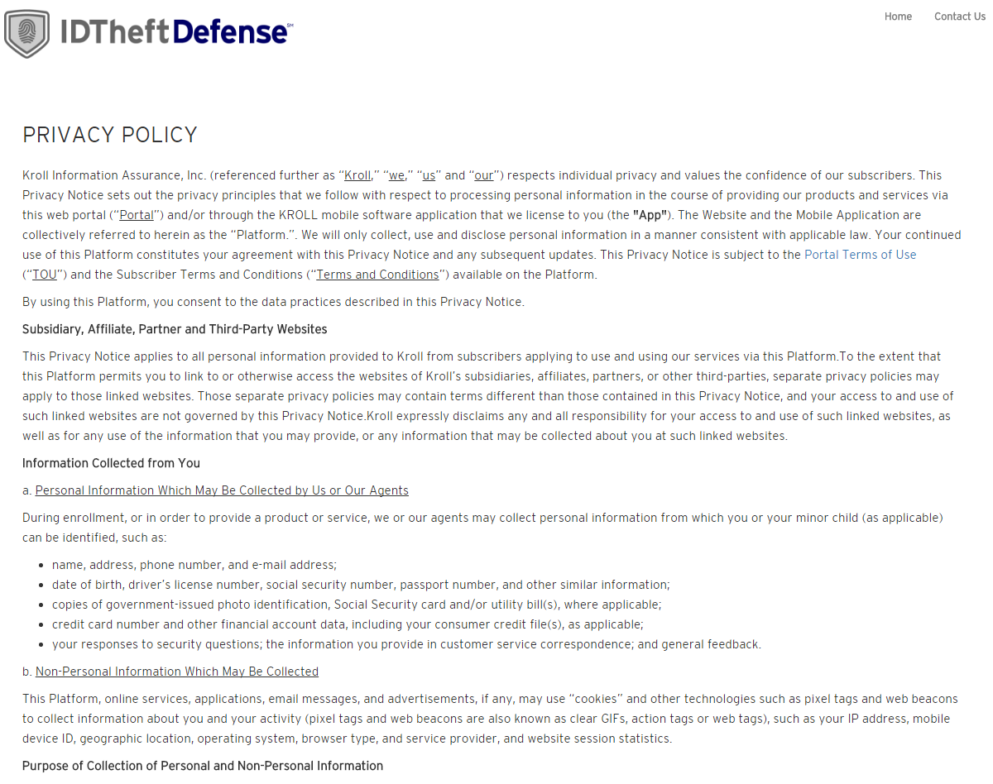

|  |  |  |
| --- | --- | --- |
| **PAGE ELEMENT** | **MULTI-CLIENT?** | **IDTD CONTENT** |
| Page Title | Yes | PRIMERICA’s Portal – PRIVACY POLICY |

# Browser Compatibility

https://idtheftdefensestage.mysecuredashboard.com/browser

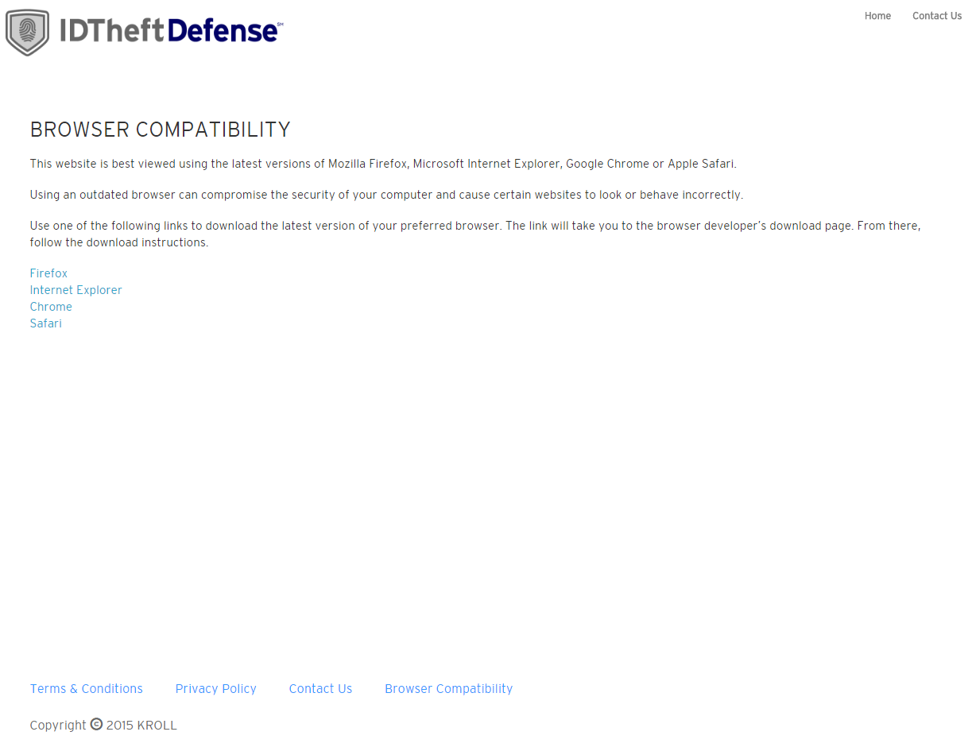

|  |  |  |
| --- | --- | --- |
| **PAGE ELEMENT** | **MULTI-CLIENT?** | **IDTD CONTENT** |
| Page Title | Yes | PRIMERICA’s Portal – Browser Compatibility |

# Having Trouble Logging In (Pop-up)

https://idtheftdefensestage.mysecuredashboard.com/having-trouble

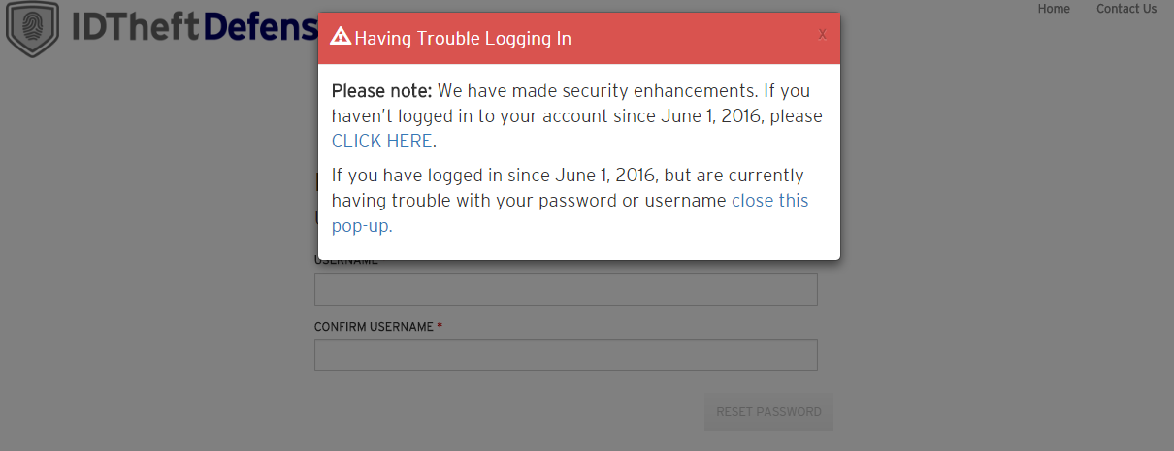

This pop-up is meant to server IDShield members primarily. ID Theft Defense members will also use the pop-up, but the impact is minimal.

The pop-up ability will need to be a multi-client feature that will need to be turned ON or OFF.

The content of the Pop-up is expected to be multi-client

|  |  |  |
| --- | --- | --- |
| **POP-UP ELEMENT** | **MULTI-CLIENT?** | **IDTD CONTENT** |
| Pop-up title | Yes | Having Trouble Logging In |
| Pop-up Content | Yes | **Please note:** We have made security enhancements. If you haven’t logged in to your account since January 3, 2017, please [CLICK HERE](https://idtheftdefensestage.mysecuredashboard.com/) [link to recover account].  If you have logged in since January 3, 2017, but are currently having trouble with your password or username [close this pop-up.](https://idtheftdefensestage.mysecuredashboard.com/) |

# Having Trouble Logging In

https://idtheftdefensestage.mysecuredashboard.com/having-trouble

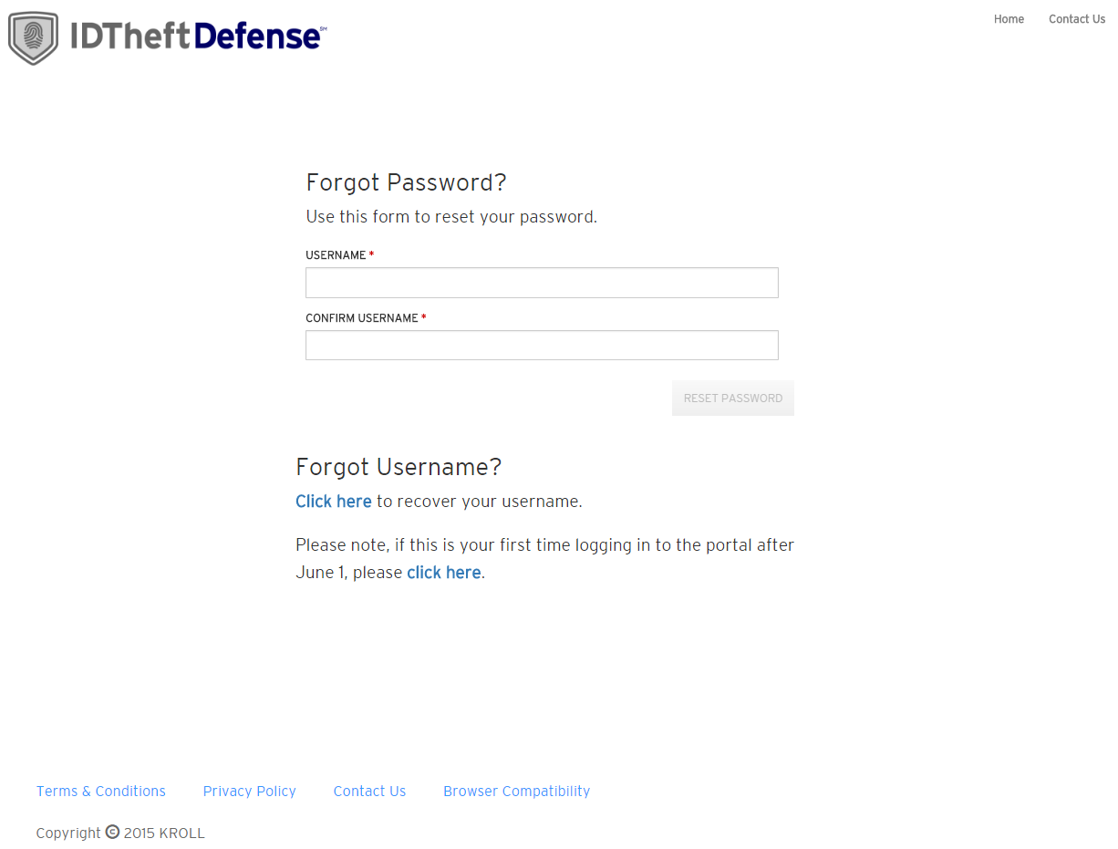

|  |  |  |
| --- | --- | --- |
| **PAGE ELEMENT** | **MULTI-CLIENT?** | **IDTD CONTENT** |
| Page Title | Yes | PRIMERICA’s Portal – Having Trouble Logging In? |
| Forgot Password section | Yes | **Forgot Password?**  Use this form to reset your password. |
| Forgot Username section (on having trouble page) | Yes | **Forgot Username?**  [**Click here**](https://idtheftdefensestage.mysecuredashboard.com/#/forgot-username) [link to forgot username] to recover your username.  Please note, if this is your first time logging in to the portal after January 3, please [**click here**](https://idtheftdefensestage.mysecuredashboard.com/#/account/recover-account) [recover account link]. |

# Forgot Username

https://idtheftdefensestage.mysecuredashboard.com/forgot-username

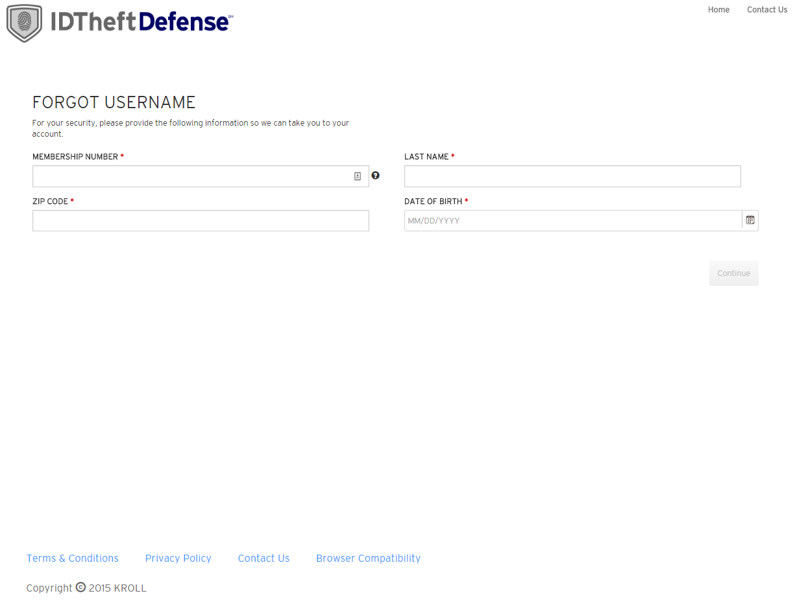

|  |  |  |
| --- | --- | --- |
| **PAGE ELEMENT** | **MULTI-CLIENT?** | **IDTD CONTENT** |
| Page Title | Yes | PRIMERICA’s Portal – Forgot Username |
| Forgot Username section | Yes | **FORGOT USERNAME**  For your security, please provide the following information so we can take you to your account**.** |

# Recover Account

https://idtheftdefensestage.mysecuredashboard.com/account/recover-account

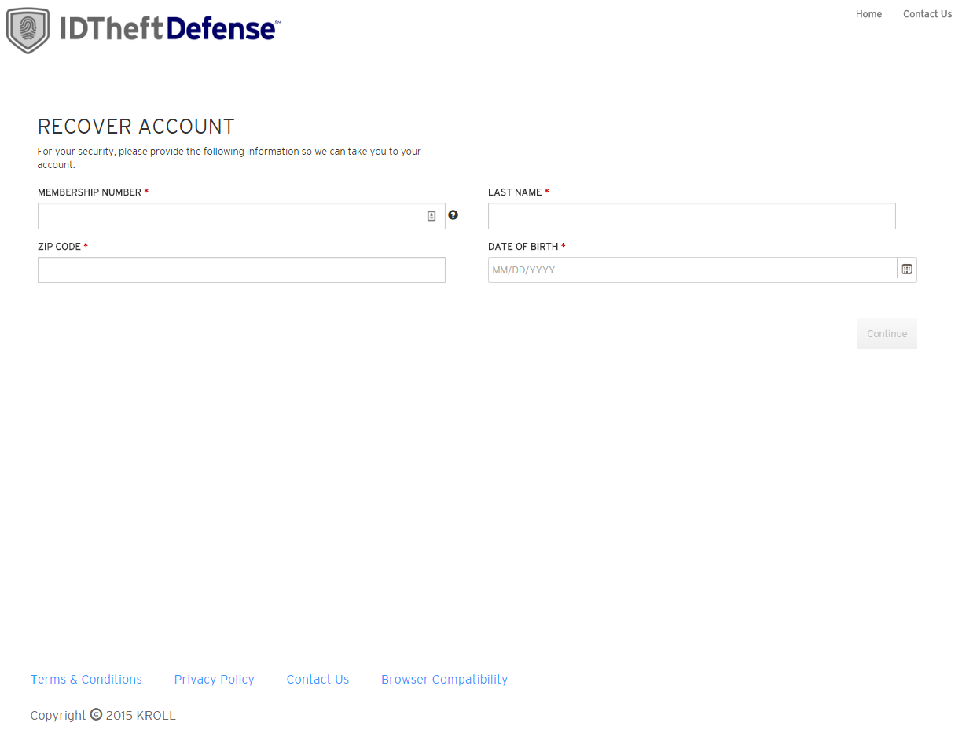

|  |  |  |
| --- | --- | --- |
| **PAGE ELEMENT** | **MULTI-CLIENT?** | **IDTD CONTENT** |
| Page Title | Yes | PRIMERICA’s Portal – Recover Account |
| Forgot Username section | Yes | **RECOVER ACCOUNT**  For your security, please provide the following information so we can take you to your account. |

# 404

https://idtheftdefensestage.mysecuredashboard.com/invalid

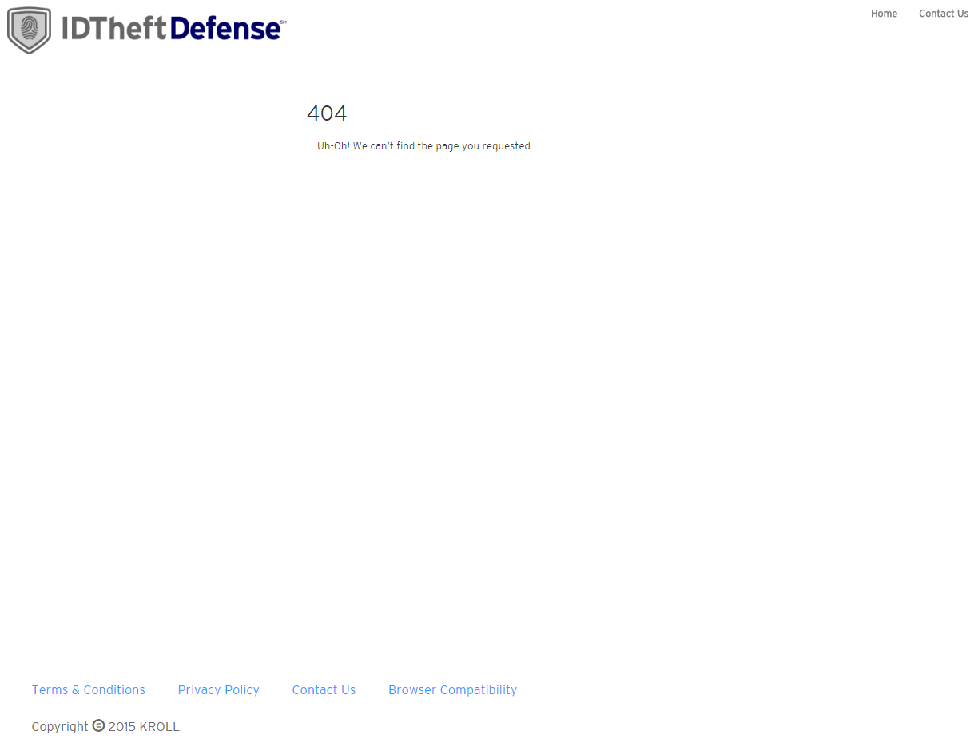

# Set Password

[Insert URL]

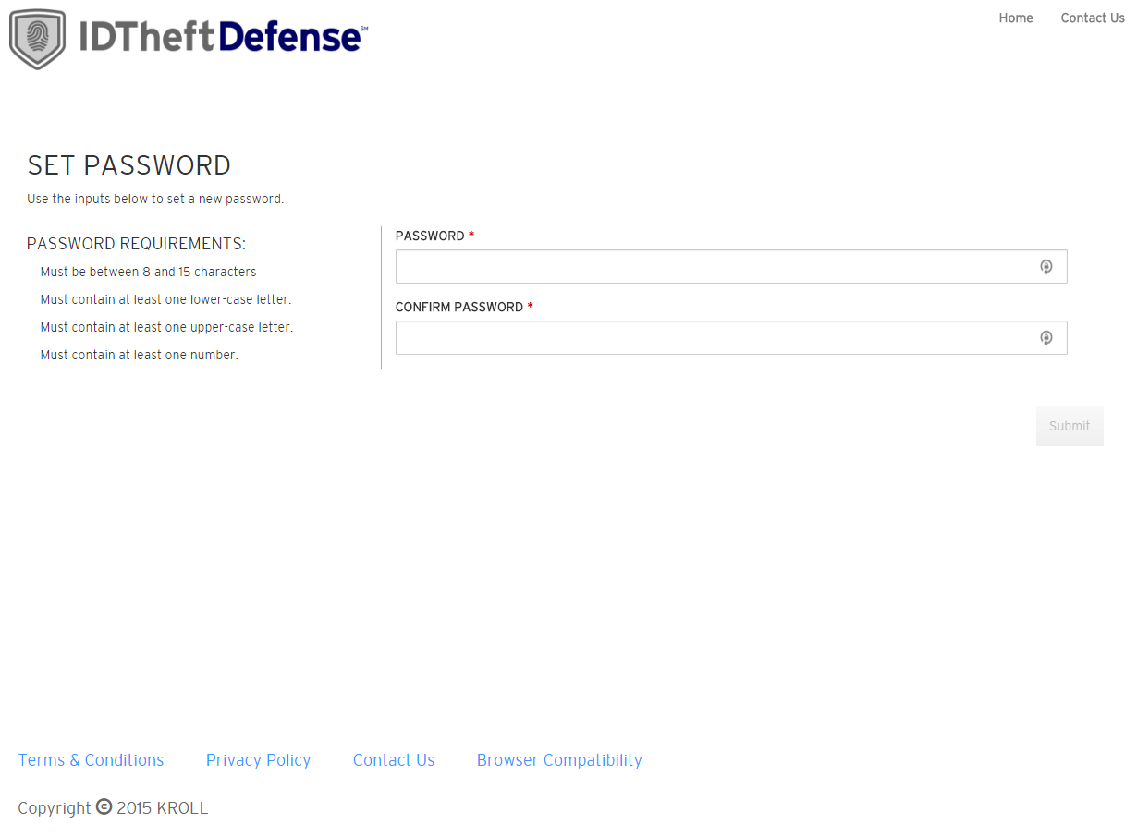

|  |  |  |
| --- | --- | --- |
| **PAGE ELEMENT** | **MULTI-CLIENT?** | **IDTD CONTENT** |
| Page Title | Yes | PRIMERICA’s Portal – Set Password |

# Password Set Success Page – will be replaced with redirect to login with success message when SSO launches

[Insert URL]

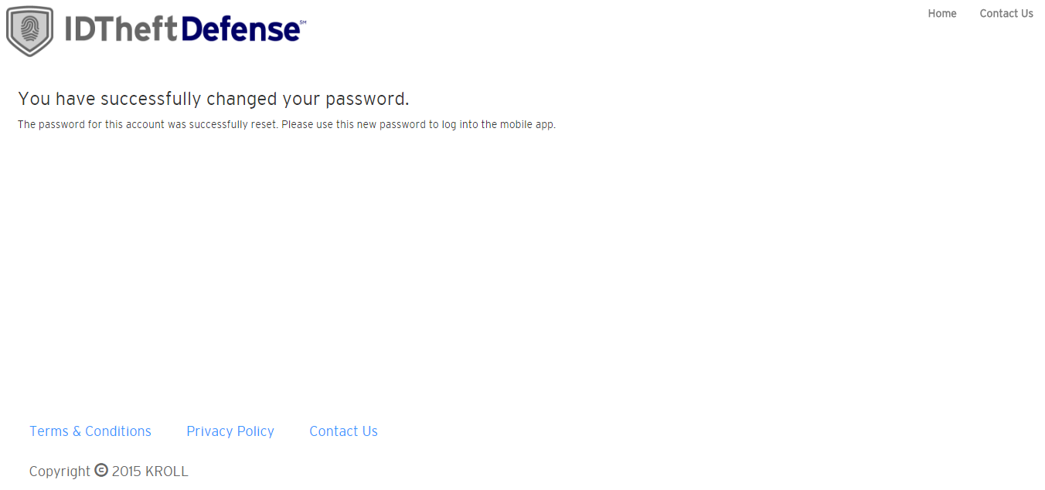

|  |  |  |
| --- | --- | --- |
| **PAGE ELEMENT** | **MULTI-CLIENT?** | **IDTD CONTENT** |
| Page Title | Yes | PRIMERICA’s Portal – Password Set Successfully |

# Profile

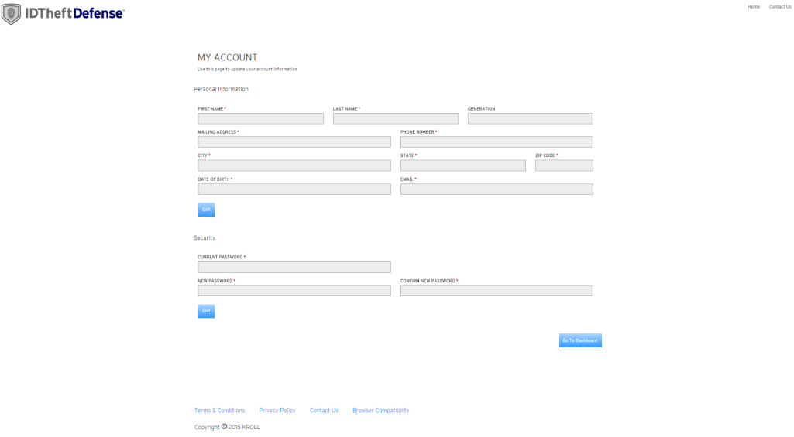

|  |  |  |
| --- | --- | --- |
| **PAGE ELEMENT** | **MULTI-CLIENT?** | **IDTD CONTENT** |
| Page Title | Yes | MY ACCOUNT |
| Text under title | Yes | Use this page to update your account information. |

# Immediate activation

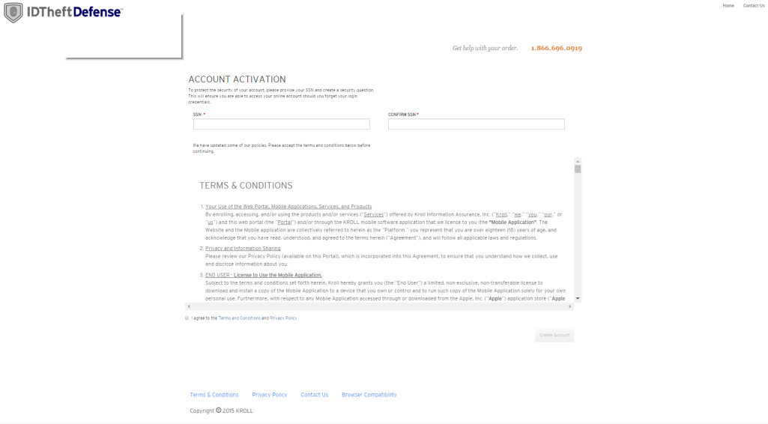

|  |  |  |
| --- | --- | --- |
| **PAGE ELEMENT** | **MULTI-CLIENT?** | **IDTD CONTENT** |
| Page Title | Yes | ACCOUNT ACTIVATION |
| Text under title | Yes | To protect the security of your account, please provide your SSN. |
| Terms and conditions instructions | Yes | Please accept the terms and conditions below before continuing. |

# Username pop-up

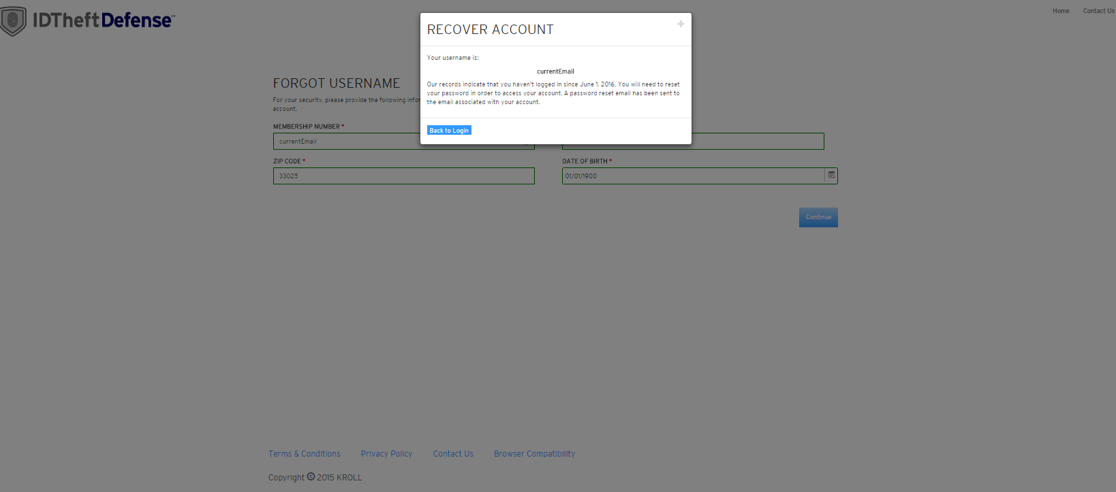

|  |  |  |
| --- | --- | --- |
| **POP-UP ELEMENT** | **MULTI-CLIENT?** | **IDTD CONTENT** |
| Pop-up Title | Yes | RECOVER ACCOUNT |
| Text under username | Yes | Our records indicate that you haven’t logged since January 3rd, 2017. You will need to reset your password in order to access your account. A password reset email has been sent to the email associated to your account. |